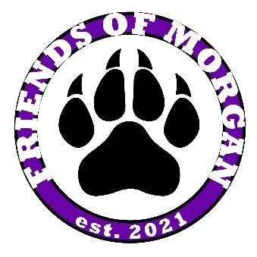
Friends of Morgan 2022-2023
Closed Board Meeting Minutes
November 4, 2022 at 9:00 am

- Meeting called to order at 9:04 am, Held at Morgan Elementary FOM room
- Attendance:
    - President- Lindsey Duke
    - Vice President- Jenn Bayes
    - VP of Programs- Amy Carlson
    - VP of Spirit- Devon Voinche
    - VP of Fundraising- Gabriel Martinez
    - Treasurer- Christy Reed
    - Secretary- Courtney Abbott
- Meeting Minutes
  - Approve open meeting minutes 10/19/22
    - Motion to approve meeting minutes from October 19, 2022 Open Meeting by Jenn Bayes. Seconded by Devon Voinche and approved.
- President Update
  - 2nd 9 weeks luncheon & Pies for teachers- November 18th
    - Local Table catering
      - Dessert pie is included in lunch
    - Canceling pies for teachers
  - Veterans Day Reception
    - Need treats-Lindsay will purchase from Sams
  - Holiday Treats
    - Simmer pot sign up
    - Set up for staff to assemble, 2 per staff member
  - Angel Tree
    - Need tree donation
  - Thankful Lunch- 11/15
    - Decorate 11/14
    - Volunteer sign up needed
  - Sponsorships
    - Community - $12,807
    - Family Paw - $5, 800
    - Movie Night- $3,300
- VP Update
  - Yearbook
    - K &5th Pictures- November 7
    - Photographer- Lorena Turner (Lorena Jean Photograpy) - $350
    - Price increase goes up November 18th
- VP of Programs Update
  - Christmas party planning
    - Sent to Gibson for approval
  - Volunteers for movie night-sign up almost full. Need a few for setup, event, and take down
  - Drink sign up-almost full, still need lemonade and game prizes
- VP of Spirit Update
  - FOM Spirit Wear
    - Friday shirts distributed
  - Store opening again
    - Pre-orders opening up again after thanksgiving, delivery after new year
- VP of Fundraising
  - Sponsors
  - Movie Night
    - Signs sent for printing
    - Need sponsors for inflatables and crafts
  - Gala Planning
    - April 28th
- Treasurer Updates
  - Budget
    - 50,000 bank balance
  - Receipts
- Secretary Update
  - Website/ Shop Update
- New Business
  - event/item for kids every 9 weeks
    - Snow cones, house color items
- Gibson Questions
  - Santa sing along?
- Meeting adjourned at ____

Upcoming Dates
- November 11- Movie Night
- November 15- Thankful lunch
- November 16- Open FOM Meeting 8am
- November 18- 2nd 9 weeks luncheon, pies for teachers, early release
- November 19-27: Thanksgiving Break
- December 2- Closed FOM Meeting 8am
- December 6- Gibson Meeting 10:30 am
- December 14- Open FOM Meeting 8am (if needed)
- December 15- Staff Treats & Holiday party set-up
- December 16- Holiday Parties/ Early Release
- December 17- January 3: Holiday Break

